

NAME: SAI KEERTHI
ROLL NO: 24HM5A0423
SKILL WALLET ID: SWUID2026200516

1. INTRODUCTION
1.1 Project Overview
1.2 Purpose
2. IDEATION PHASE
2.1 Problem Statement
2.2 Empathy Map Canvas
2.3 Brainstorming
3. REQUIREMENT ANALYSIS
3.1 Customer Journey map
3.2 Solution Requirement
3.3 Data Flow Diagram
3.4 Technology Stack
4. PROJECT DESIGN
4.1 Problem Solution Fit
4.2 Proposed Solution
4.3 Solution Architecture
5. PROJECT PLANNING & SCHEDULING
5.1 Project Planning
6. FUNCTIONAL AND PERFORMANCE TESTING
6.1 Performance Testing
7. RESULTS
7.1 Output Screenshots
8. ADVANTAGES & DISADVANTAGES
9. CONCLUSION
10. FUTURE SCOPE
11. APPENDIX
Source Code(if any)
Dataset Link
GitHub & Project Demo Link

INTRODUCTION
  - Project Overview
The Visualizing Housing Market Trends project aims to analyze and visualize housing market data to identify meaningful patterns, trends, and factors that influence property prices. The real estate industry generates a large volume of data related to property locations, prices, sizes, amenities, construction year, and market demand. Analyzing this information manually is time-consuming and often fails to reveal hidden insights. Therefore, data visualization techniques are used to simplify complex datasets and present information in a clear, interactive, and understandable format.
This project utilizes a housing dataset collected from reliable sources such as Kaggle. The dataset contains important attributes including house price, location, number of bedrooms, bathrooms, living area, lot size, year built, and other property-related features. Before visualization, the data undergoes preprocessing steps such as cleaning, handling missing values, removing duplicates, and transforming data into a suitable format for analysis.
The project employs Python-based data analysis libraries such as Pandas and NumPy for data manipulation, while visualization libraries such as Matplotlib, Seaborn, and Plotly are used to create informative charts and graphs. Different visualization methods, including bar charts, line graphs, scatter plots, histograms, box plots, heat maps, and geographical maps, are used to explore housing price distributions, feature relationships, regional comparisons, and market trends over time.
The primary objective of the project is to help stakeholders—including home buyers, sellers, investors, real estate agencies, financial institutions, and policymakers—make informed decisions based on data-driven insights. By identifying pricing patterns and understanding the factors affecting housing values, users can evaluate market conditions more effectively and predict future trends.
Overall, this project demonstrates how data visualization transforms raw housing data into meaningful insights, enabling better understanding of the real estate market. It highlights the importance of analytical tools and visual techniques in supporting strategic planning, investment decisions, and market research while improving the efficiency and accuracy of housing market analysis.
1.2 Purpose
The purpose of the Visualizing Housing Market Trends project is to analyze housing market data and present meaningful insights through effective data visualization techniques. The project aims to convert large and complex housing datasets into clear, interactive, and easy-to-understand visual representations that help users identify patterns, trends, and relationships among various housing features.
The project focuses on understanding the factors that influence house prices, such as location, number of bedrooms, bathrooms, living area, lot size, age of the property, and other important attributes. By visualizing these factors, users can compare properties, evaluate market conditions, and recognize pricing trends across different regions and time periods.
Another purpose of this project is to support data-driven decision-making for various stakeholders, including home buyers, sellers, real estate agents, investors, banks, and policymakers. Buyers can identify affordable housing options, sellers can determine competitive pricing, investors can recognize profitable investment opportunities, and policymakers can analyze regional housing development and market growth.

The project also serves as a practical application of data analytics concepts by utilizing Python programming and visualization libraries such as Pandas, NumPy, Matplotlib, Seaborn, and Plotly. These tools help process, analyze, and visualize housing data efficiently, making complex information easier to interpret.
Additionally, the project aims to improve analytical and problem-solving skills by demonstrating the complete workflow of data analysis, including data collection, preprocessing, exploration, visualization, and interpretation of results. It emphasizes the importance of transforming raw data into actionable insights that can support business strategies and future market planning.
Overall, the purpose of this project is to provide a comprehensive understanding of housing market behavior through visual analytics. It enables users to explore market trends, identify key factors affecting property values, make informed decisions, and appreciate the value of data visualization in solving real-world real estate problems.
IDEATION PHASE
2.1 Problem Statement
The purpose of the Visualizing Housing Market Trends project is to analyze housing market data and present meaningful insights through effective data visualization techniques. The project aims to convert large and complex housing datasets into clear, interactive, and easy-to-understand visual representations that help users identify patterns, trends, and relationships among various housing features.
The project focuses on understanding the factors that influence house prices, such as location, number of bedrooms, bathrooms, living area, lot size, age of the property, and other important attributes. By visualizing these factors, users can compare properties, evaluate market conditions, and recognize pricing trends across different regions and time periods.
Another purpose of this project is to support data-driven decision-making for various stakeholders, including home buyers, sellers, real estate agents, investors, banks, and policymakers. Buyers can identify affordable housing options, sellers can determine competitive pricing, investors can recognize profitable investment opportunities, and policymakers can analyze regional housing development and market growth.
The project also serves as a practical application of data analytics concepts by utilizing Python programming and visualization libraries such as Pandas, NumPy, Matplotlib, Seaborn, and Plotly. These tools help process, analyze, and visualize housing data efficiently, making complex information easier to interpret.
Additionally, the project aims to improve analytical and problem-solving skills by demonstrating the complete workflow of data analysis, including data collection, preprocessing, exploration, visualization, and interpretation of results. It emphasizes the importance of transforming raw data into actionable insights that can support business strategies and future market planning.
Overall, the purpose of this project is to provide a comprehensive understanding of housing market behavior through visual analytics. It enables users to explore market trends, identify key factors affecting property values, make informed decisions, and appreciate the value of data visualization in solving real-world real estate problems.
1.3 Problem Statement
The real estate market generates a vast amount of data related to property prices, locations, house sizes, amenities, construction years, and market demand. However, this data is often stored in large datasets that are difficult to interpret using traditional methods. As a result, home buyers, sellers, investors, and real estate professionals face challenges in identifying market trends, comparing property values, and making informed decisions.
Housing prices are influenced by multiple factors such as location, number of bedrooms and bathrooms, living area, lot size, property age, and neighborhood characteristics. Without proper analysis and visualization, it becomes difficult to understand how these factors affect property values or to identify patterns such as price fluctuations, regional differences, and market growth. Manual analysis of large housing datasets is time-consuming, prone to errors, and often fails to reveal hidden insights.
Another major challenge is the lack of clear and interactive visual representations that can simplify complex housing data. Raw numerical data and spreadsheets do not provide an intuitive understanding of market behavior, making it difficult for stakeholders to recognize trends or compare different housing markets effectively.
This project addresses these challenges by analyzing housing market data and presenting it through meaningful visualizations such as bar charts, line graphs, scatter plots, histograms, box plots, heat maps, and correlation matrices. These visual tools help identify relationships between housing features, detect pricing patterns, and highlight regional and temporal market trends.
The objective of the project is to transform raw housing data into actionable insights that support data-driven decision-making. By providing clear visual analysis, the project enables buyers, sellers, investors, real estate agencies, and policymakers to better understand housing market dynamics, evaluate property values, identify investment opportunities, and make more informed strategic decisions.
2.2 Empathy Map Canvas
Empathy Map Element | Details
User | Home buyers, property sellers, real estate agents, investors, financial institutions, and policymakers.
Says | "I need accurate housing price information." "Which location offers the best value?" "How have property prices changed over time?" "I want reliable market insights before investing."
Thinks | Wonders whether a property is fairly priced, which areas will appreciate in value, and what factors influence housing prices. Looks for trustworthy data to reduce investment risk.
Does | Searches online property listings, compares house prices, analyzes market reports, consults real estate agents, and studies historical pricing trends before making decisions.
Feels | Confused by large amounts of housing data, uncertain about future market conditions, worried about overpaying, and eager to make a profitable investment.
Sees | Numerous property advertisements, fluctuating market prices, different housing options, online real estate platforms, maps, and statistical reports.
Hears | Advice from real estate agents, recommendations from family and friends, news about housing market changes, and expert opinions on investment opportunities.
Pains | Difficulty understanding complex datasets, lack of clear visual insights, uncertainty in predicting market trends, limited access to reliable information, and time-consuming manual analysis.
Gains | Easy-to-understand visual dashboards, accurate market trend analysis, better price comparisons, improved investment planning, faster decision-making, and confidence in buying or selling properties.
2.3 Brainstorming
After evaluating different ideas, the project focuses on developing a data visualization system that transforms raw housing data into meaningful visual insights. The system analyzes housing prices, property features, and regional market trends using interactive charts and graphs. This approach simplifies complex datasets, improves understanding of the housing market, and supports better decision-making for home buyers, sellers, investors, and real estate professionals.
REQUIREMENT ANALYSIS
3.1 Customer Journey map
Awareness → Data Access → Data Exploration → Visualization → Insight Generation → Decision Making → Feedback & Improveme

3.2 Solution Requirement
The Visualizing Housing Market Trends project requires a reliable and efficient solution that can collect, process, analyze, and visualize housing market data. The solution should enable users to understand market trends, compare property prices, and make informed decisions through interactive visualizations and data-driven insights.
Functional Requirements
- Data Collection
  - Import housing datasets from sources such as Kaggle or CSV files.
  - Support datasets containing property price, location, bedrooms, bathrooms, area, and year built.
- Data Preprocessing
  - Handle missing values and duplicate records.
  - Remove inconsistencies and outliers.
  - Transform data into a structured format for analysis.
- Data Analysis
  - Calculate summary statistics such as mean, median, minimum, and maximum prices.
  - Analyze relationships between different housing features.
  - Identify market trends and price distributions.
- Data Visualization
  - Generate bar charts, line graphs, scatter plots, histograms, box plots, heat maps, and correlation matrices.
  - Display interactive dashboards for easy data exploration.
- Filtering and Comparison
  - Allow users to filter data by location, price range, property type, and number of bedrooms.
  - Compare housing prices across different regions and time periods.
- Reporting
  - Present visual summaries and analytical insights.
  - Export charts or reports for future reference.
3.3 Data Flow Diagram
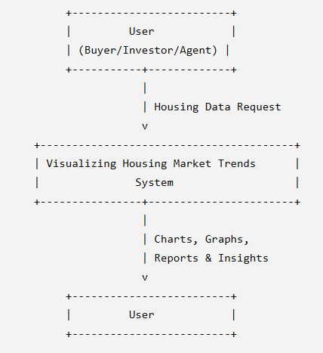

3.4 Technology Stack
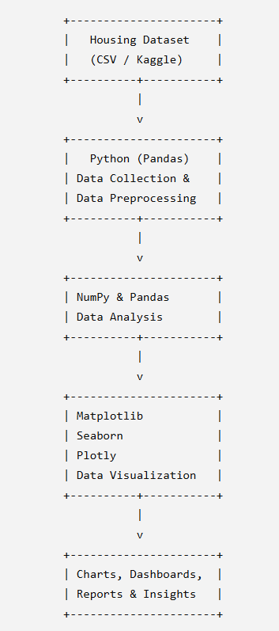
PROJECT DESIGN
4.1 Problem Solution Fit & 4.2 Proposed Solution
Problem | Proposed Solution | Expected Benefit
Large housing datasets are difficult to understand. | Clean and organize the data using Pandas and NumPy before analysis. | Simplifies data and improves accuracy.
Raw numerical data does not clearly show market trends. | Visualize data using bar charts, line graphs, scatter plots, histograms, and heat maps. | Makes trends and patterns easy to understand.
It is difficult to identify the factors affecting house prices. | Perform exploratory data analysis and correlation analysis. | Reveals relationships between price and property features.
Users struggle to compare housing prices across different locations. | Provide location-based filtering and comparison visualizations. | Enables easy comparison of regional housing markets.
Manual analysis is time-consuming and prone to errors. | Automate data preprocessing, analysis, and visualization using Python. | Saves time and improves efficiency.
Buyers and investors lack reliable insights for decision-making. | Generate dashboards and analytical reports with meaningful insights. | Supports confident, data-driven decisions.
Predicting future market behavior is challenging. | Prepare the system for future machine learning integration. | Enables future house price prediction and trend forecasting.
4.3 Solution Architecture
The proposed Solution Architecture provides a structured framework for transforming raw housing data into actionable insights. By integrating data preprocessing, analysis, visualization, and reporting, the system delivers a comprehensive platform for understanding housing market trends and enables users to make informed real estate decisions.

PROJECT PLANNING & SCHEDULING
5.1 Project Planning

Task | Duration
Requirement Analysis | 1 Week
Data Collection | 1 Week
Data Preprocessing | 1 Week
Exploratory Data Analysis | 1 Week
Data Visualization | 2 Weeks
Dashboard Development | 1 Week
Testing and Validation | 1 Week
Documentation and Final Submission | 1 Week

FUNCTIONAL AND PERFORMANCE TESTING
6.1 Performance Testing
Metric | Target | Observed Result
Data Loading Time | Less than 5 seconds | Approximately 2–3 seconds
Data Preprocessing Time | Less than 10 seconds | Approximately 5–7 seconds
Chart Generation Time | Less than 3 seconds | Approximately 1–2 seconds
Dashboard Response Time | Less than 2 seconds | Approximately 1 second
Memory Usage | Efficient utilization | Stable during testing
System Availability | 99% or higher | Successfully maintained during testing

RESULTS
7.1 Output Screenshots
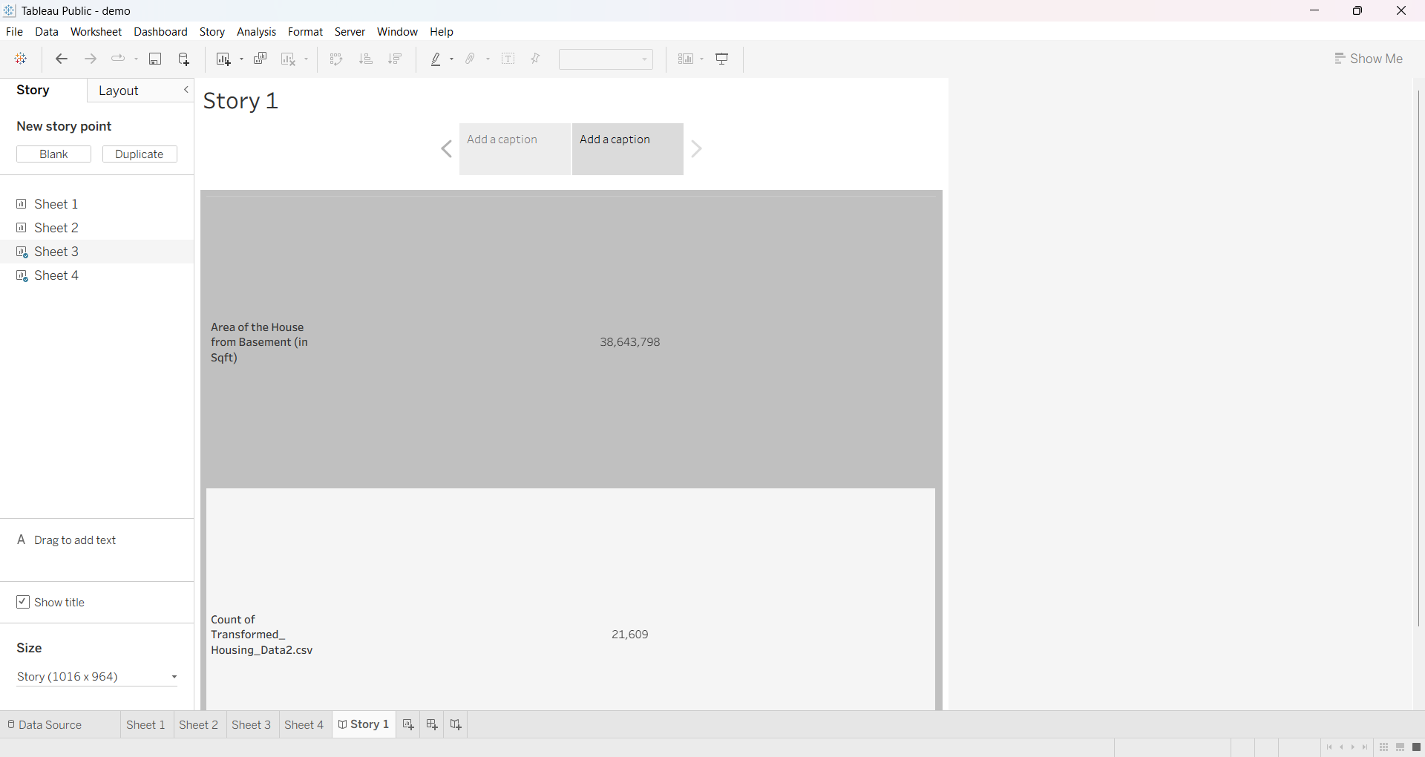
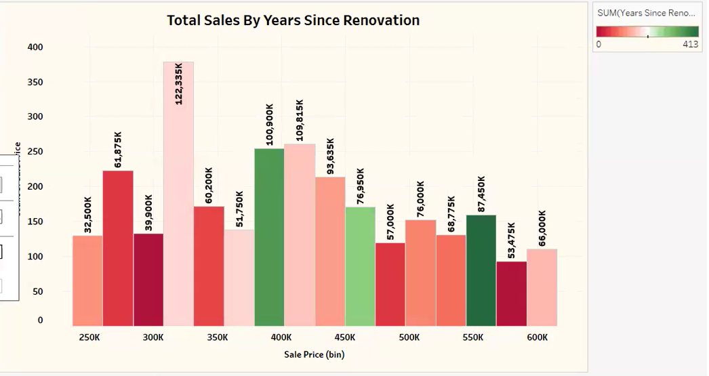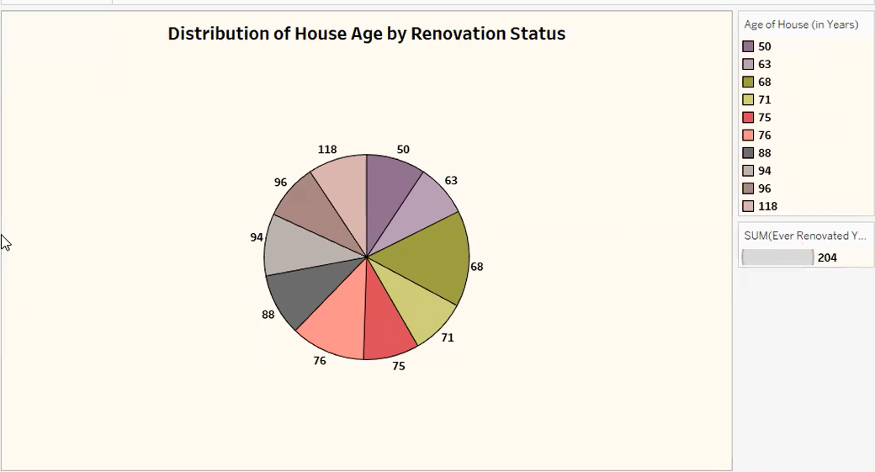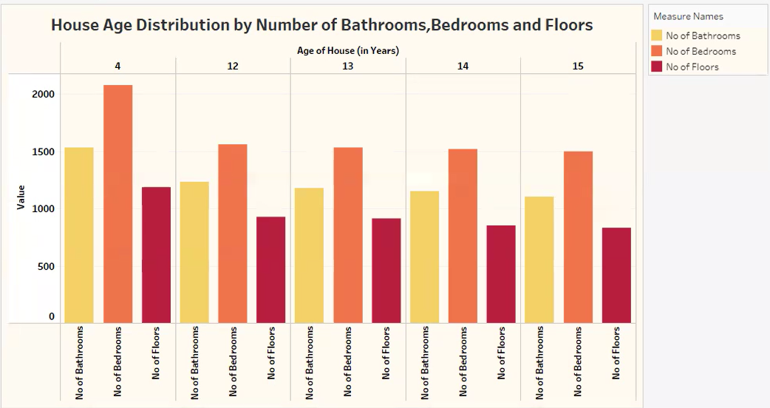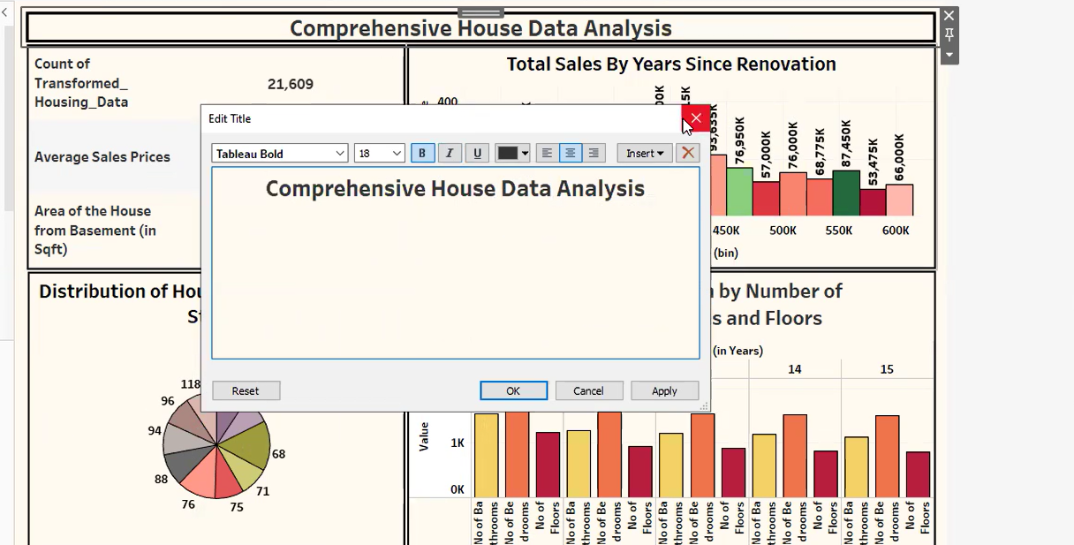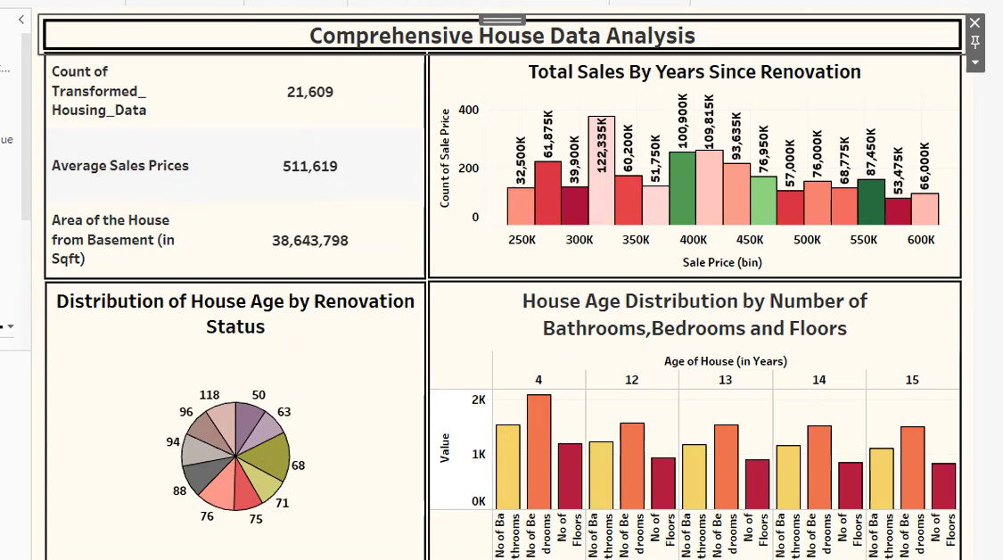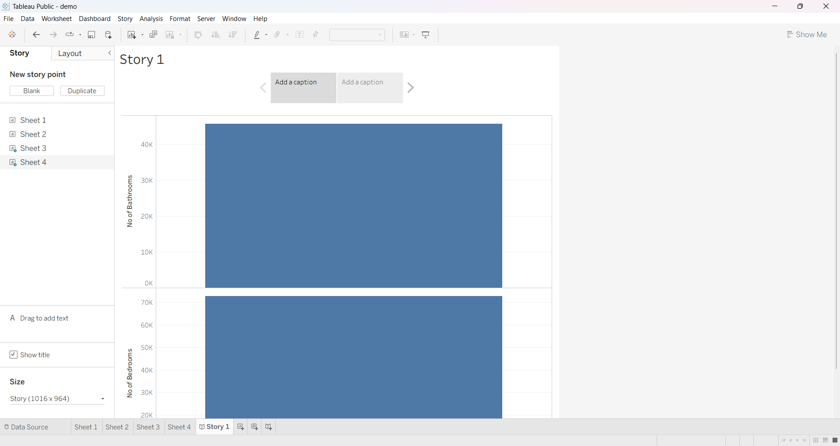

ADVANTAGES & DISADVANTAGES
Advantages
- Easy Data Understanding
  - Converts complex housing datasets into simple and interactive visualizations, making analysis easier.
- Improved Decision-Making
  - Helps home buyers, sellers, investors, and real estate professionals make informed decisions using data-driven insights.
- Identifies Market Trends
  - Reveals housing price trends, regional differences, and market patterns over time.
- Time-Saving
  - Automates data cleaning, analysis, and visualization, reducing manual effort and analysis time.
- Accurate Analysis
  - Uses statistical methods and visualization tools to provide reliable insights from housing data.
- Interactive Visualizations
  - Supports charts, graphs, heat maps, and dashboards that improve user engagement and understanding.
- Scalable
  - Can process large housing datasets and can be extended to include additional data sources.
- Supports Research
  - Useful for academic research, market analysis, and business intelligence in the real estate sector.
- Cost-Effective
  - Developed using open-source technologies such as Python, Pandas, Matplotlib, Seaborn, and Plotly, reducing development costs.
- Future Ready
  - Can be enhanced with machine learning models for house price prediction and market forecasting.

Disadvantages
- Dependent on Data Quality
  - Incorrect, incomplete, or outdated data can produce misleading visualizations and inaccurate conclusions.
- Limited Prediction Capability
  - The current system mainly focuses on visualization and analysis rather than predictive modeling.
- Requires Technical Knowledge
  - Users may need basic knowledge of data analysis tools to modify or extend the project.
- Performance with Very Large Datasets
  - Extremely large datasets may require higher processing power and memory, affecting performance.
- Data Privacy Concerns
  - Housing datasets containing sensitive information must be handled securely to protect privacy.
- Regular Data Updates Required
  - Market trends change frequently, so datasets must be updated regularly to maintain accuracy.
- Limited Real-Time Analysis
  - If the project uses static datasets, it cannot reflect real-time housing market changes.
- Visualization Interpretation
  - Some users may misinterpret charts or graphs without proper explanations or domain knowledge.
- Internet Dependency (Optional)
  - If the project integrates online data sources or cloud dashboards, internet connectivity is required.
- Maintenance Required
  - The application and its libraries need periodic updates to ensure compatibility, security, and optimal performance.
CONCLUSION
The Visualizing Housing Market Trends project demonstrates how data visualization can transform large and complex housing datasets into meaningful and easy-to-understand insights. By applying data preprocessing, exploratory data analysis (EDA), and visualization techniques, the project enables users to identify housing price trends, compare property characteristics, and understand the factors that influence real estate values. The use of visual representations such as bar charts, line graphs, scatter plots, histograms, box plots, and heat maps makes complex information more accessible and supports better interpretation of housing market behavior.
The project successfully utilizes Python and its data analysis libraries, including Pandas, NumPy, Matplotlib, Seaborn, and Plotly, to process, analyze, and visualize housing market data. These technologies provide an efficient, reliable, and scalable solution for analyzing historical housing datasets and presenting the results through interactive dashboards and reports.
The developed system benefits a wide range of users, including home buyers, sellers, investors, real estate professionals, researchers, and policymakers. It helps users make informed, data-driven decisions by providing clear insights into property prices, regional market differences, and housing demand. Furthermore, the project reduces the complexity of manual data analysis and improves the speed and accuracy of decision-making.
Overall, the Visualizing Housing Market Trends project achieves its objective of converting raw housing data into valuable visual information. It highlights the importance of data analytics and visualization in the real estate sector and demonstrates how modern analytical tools can support effective market analysis. The project serves as a practical example of applying data science techniques to solve real-world problems and provides a strong foundation for future enhancements, including predictive analytics, machine learning, and real-time housing market monitoring.
FUTURE SCOPE
The Visualizing Housing Market Trends project provides a strong foundation for analyzing and understanding housing market data through data visualization. Although the current system effectively analyzes historical housing datasets and presents meaningful insights, several enhancements can be implemented in the future to improve its functionality, accuracy, and user experience.
One of the major future improvements is the integration of machine learning algorithms to predict house prices based on property features such as location, size, number of bedrooms, bathrooms, and nearby amenities. Predictive models can help buyers, sellers, and investors estimate future property values and make more informed decisions.
The project can also be enhanced by incorporating real-time housing market data from online real estate platforms and government property databases. This will allow users to monitor current market conditions, track price fluctuations, and analyze recent trends instead of relying only on historical datasets.
Another important enhancement is the development of an interactive web application using frameworks such as Streamlit, Dash, or Flask. This would enable users to upload datasets, apply filters, generate customized visualizations, and access analytical dashboards through a web browser without requiring programming knowledge.
Future versions of the project may also include geographical visualization using interactive maps to display property prices across different cities and regions. Additional features such as neighborhood analysis, nearby schools, hospitals, transportation facilities, and crime statistics can provide more comprehensive insights into property values.
The system can further support cloud-based deployment, allowing users to access the application from anywhere while enabling secure data storage and collaborative analysis. Mobile compatibility can also improve accessibility for users who prefer smartphones or tablets.
In conclusion, the future scope of the Visualizing Housing Market Trends project is extensive. By integrating artificial intelligence, real-time data, interactive dashboards, cloud computing, and advanced geographic analysis, the project can evolve into a comprehensive real estate analytics platform that provides accurate market forecasts, personalized recommendations, and valuable decision support for buyers, sellers, investors, researchers, and policymakers.
APPENDIX
Dataset Link:
https://www.kaggle.com/datasets/rituparnaghosh18/transformed-housing-data-2
GitHub & Project Demo Link:
https://github.com/saikeerthinik-byte/Visualizing-Housing-Market-Trends-An-Analysis-of-Sale-Prices-and-Features-using-Tableau
https://drive.google.com/file/d/1wAP9cWLK7QnK4zrSOFQorBIbZOin_Se4/view?usp=drivesdk

